**AI PROGRAMMING**

**\*\*\***

**FINAL EXAMINATION**

**Deadline 15/4/2022**

**Question 1. Algebra**

***Assume a product has info with 5 properties (weight (gram), width (cm), height (cm), color, price (USD)).***

***(Color :1 (Red), 2 (Blue), 3 (Green), 4 (Yellow), 5(White), 7(Purple), 8(Black), 9(Magenta), 10(Cyan))***

1. ***Please input two vectors representing information of two products: A and B. And calculate the dot product of two vectors, the angle between two vectors***

Example:

Please input product A ==> Input : 3.5, 12, 5, 5, 10

==> Vector of A is [3.5, 12, 5, 5, 10]

Please input product B ==> Input : 2.5, 10, 4, 5, 12

==> Vector of B is [2.5, 10, 4, 5, 12]

==> Dot Product is : 25 and Angle two vectors are : 15 degree

(Note: The value is just example not exact the result)

1. ***Create a random of 200 products and apply PCA to help reduce the dimensions of data from 5 to 4,3, and 2. Print out step by step of PCA with mean, covariance, eigenvalue, eigenvector and product vectors (after reduce)***

Example: call functions

X = GenerateProducts(num = 200)

==> List of random 200 products with 5 properties are : <<Output Here>>

X_Reduce = PCA_DimensionReduce(X, reduce_dim = 3)

==> Means = <<Output Here>>

==> Cov = <<Output Here>>

==> EigenValue = <<Output Here>>

==> EighenVector = <<Output Here>>

==> List of random 200 products with 3 properties are : <<Output Here>>

**Question 2. Calculus**

**Assume the loss function of an AI algorithm is y = x3 - 2*x2 + 1.**

1. **Plot the function in plane and its derivative**
2. **Using the Gradient Descent to find the x to make this function get the minimum loss.**

**Question 3. Statistics**

**Make use of the make_blobs from the library sklearns.datasets to create three groups/classes:**

(The following code is to make use of this function to create two groups)

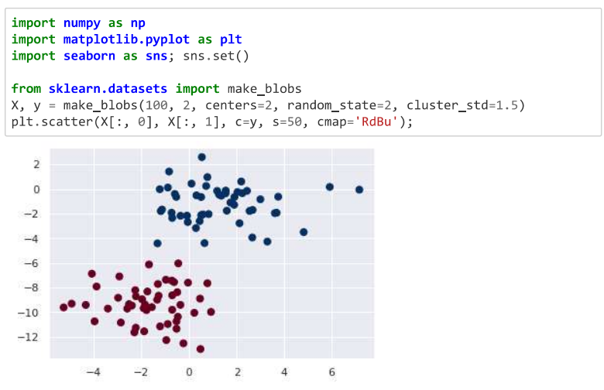

**A Apply GaussianNB to learn on these data and plot about 2000 random points in the plane with corresponding colors to its class prediction. Print out the mean and standard deviation of each groups after learning**

(Here is example of two groups)

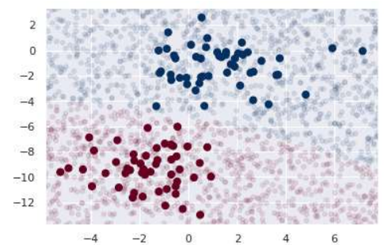

B **Given the transition table**

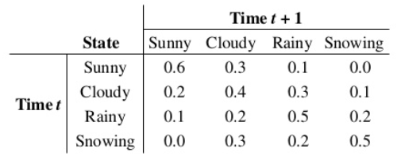

**Use Markov chain to print out after three days, what is the weather ? and what is probability ? if the today input is Rainy**.

**Grading Scale**

* Question 1 : 35 %
* Question 2 : 35 %
* Question 3 : 30 %